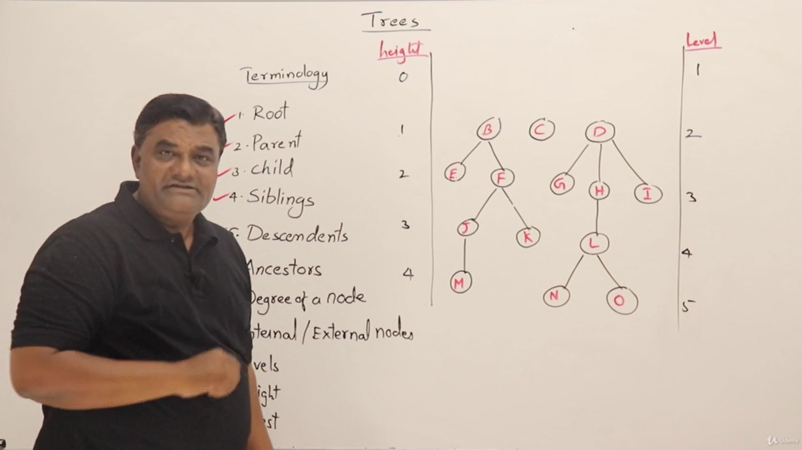

height 🡪 starts from the edges

level 🡪 starts from the node

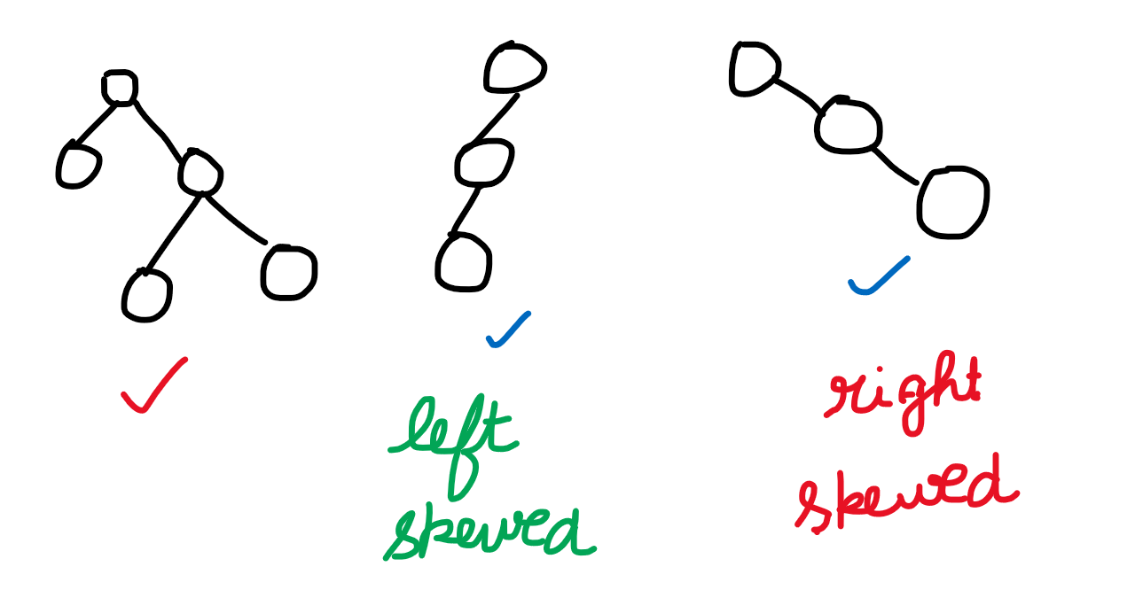

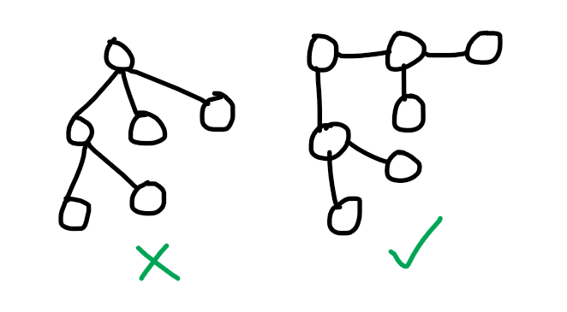

**Binary Trees**

**Unlabelled Nodes** **Labelled Nodes**

**Unlabelled Nodes**

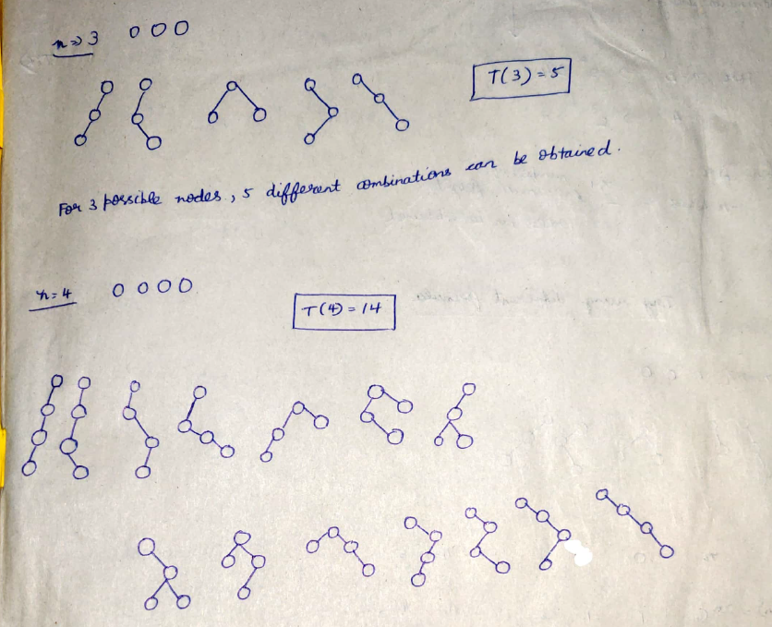  
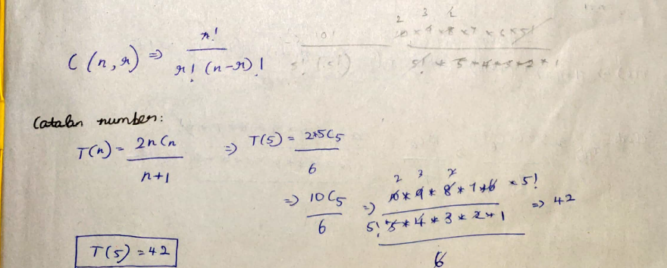

Number of binary trees with given unlabelled nodes 🡪   
Catalan Number T(n)=2*n Cn / (n+1) (or) T(n) = $\sum_{i=1}^{n}{[ T(i-1)*T(n-i) }]$  
Number of binary trees having maximum height 🡪 2^(n-1)

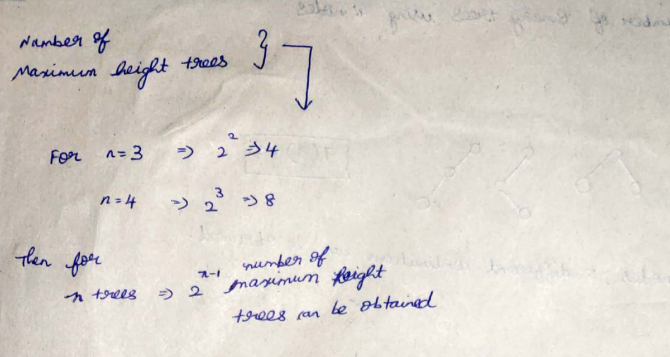  
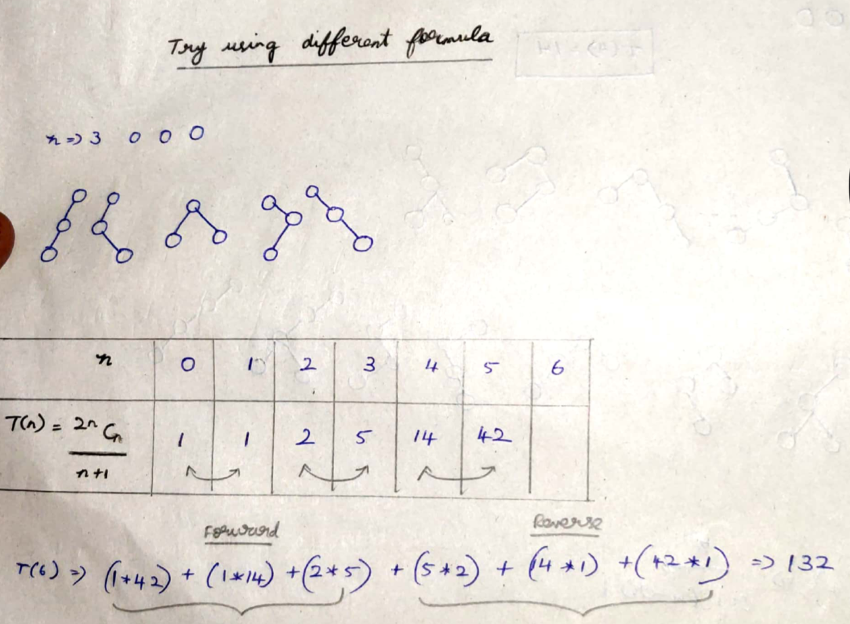

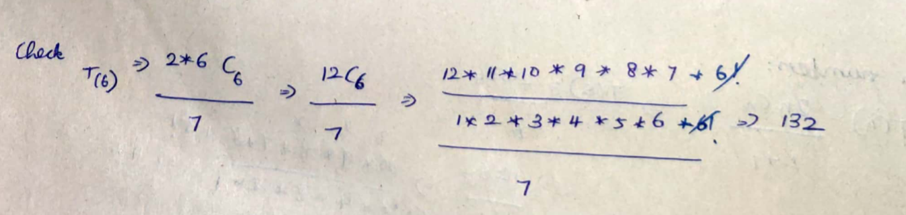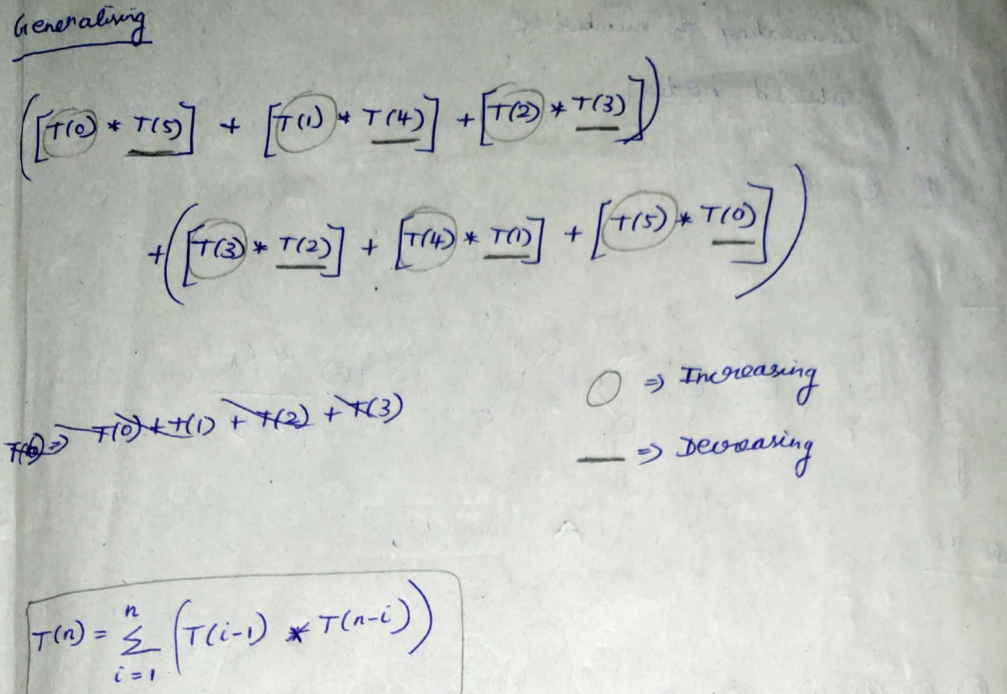  
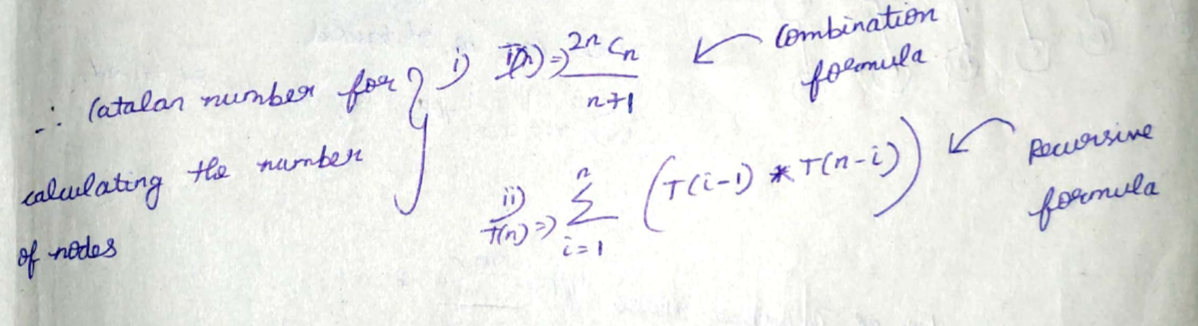

**Labelled Nodes**

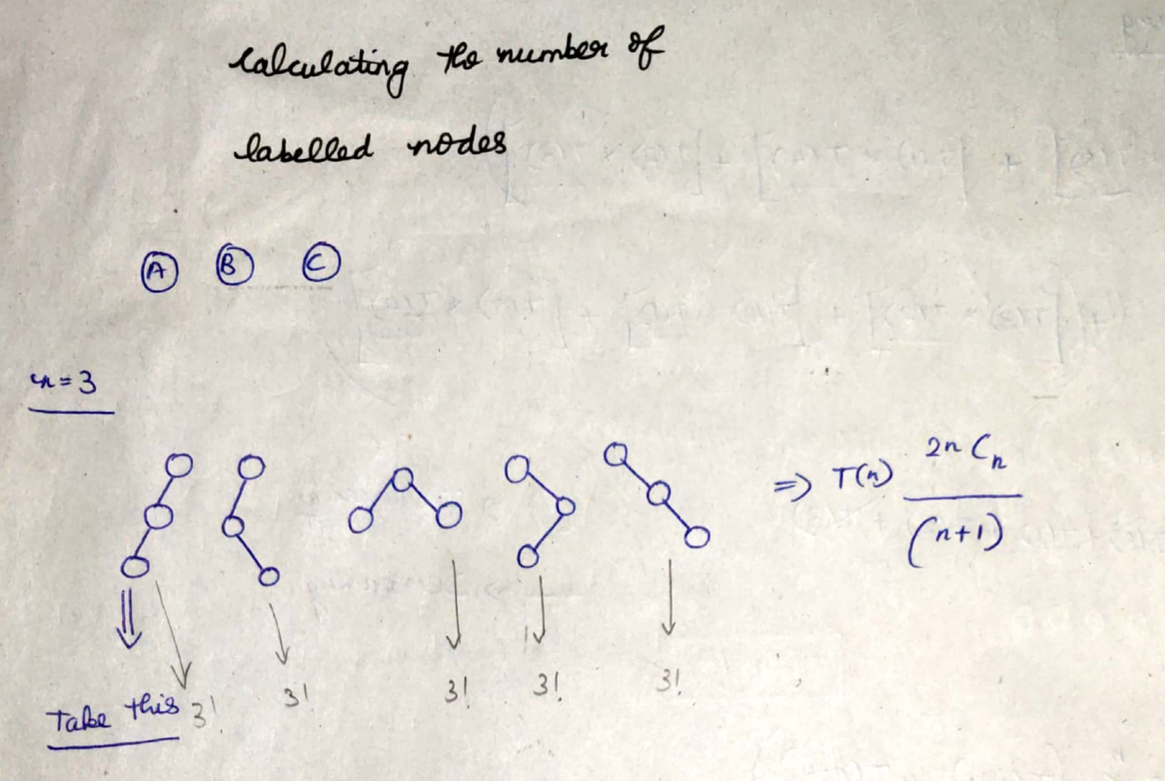  
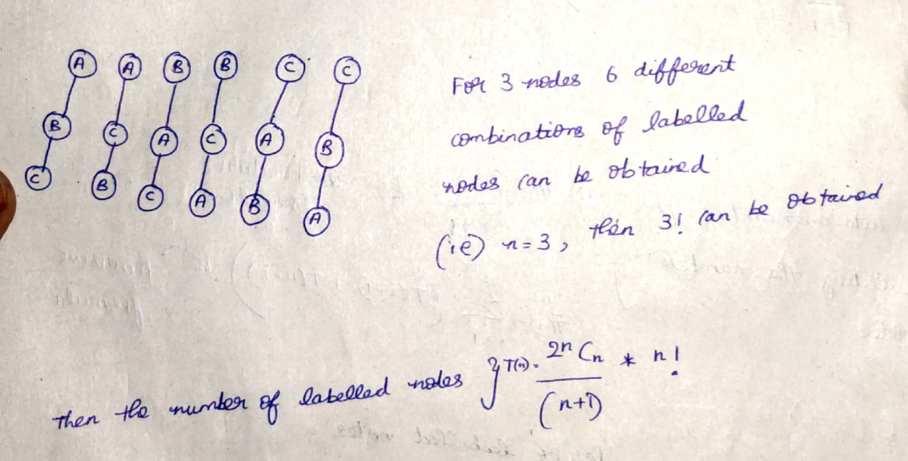  
Number of binary trees with given labelled nodes 🡪   
Catalan Number T(n) = (2*n Cn / (n+1) ) * n!

**Heights vs Nodes in Binary Trees**

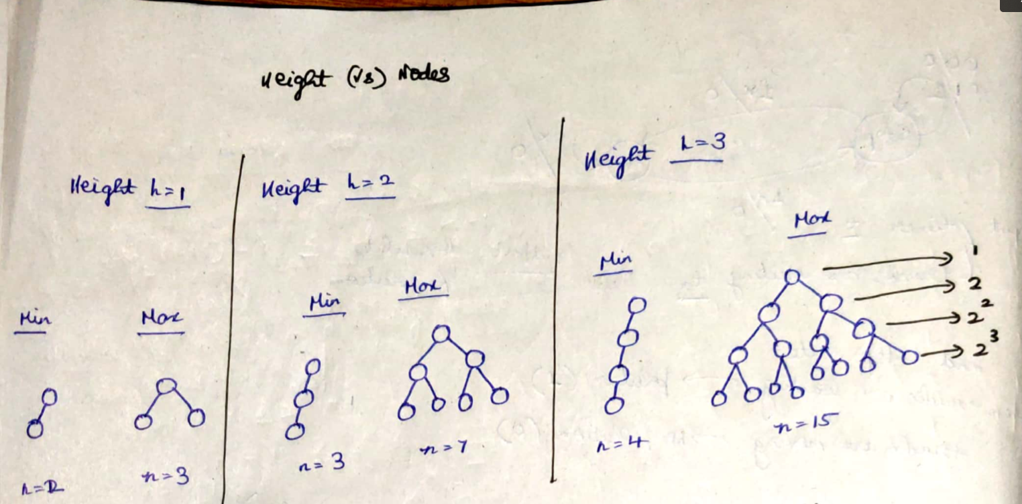  
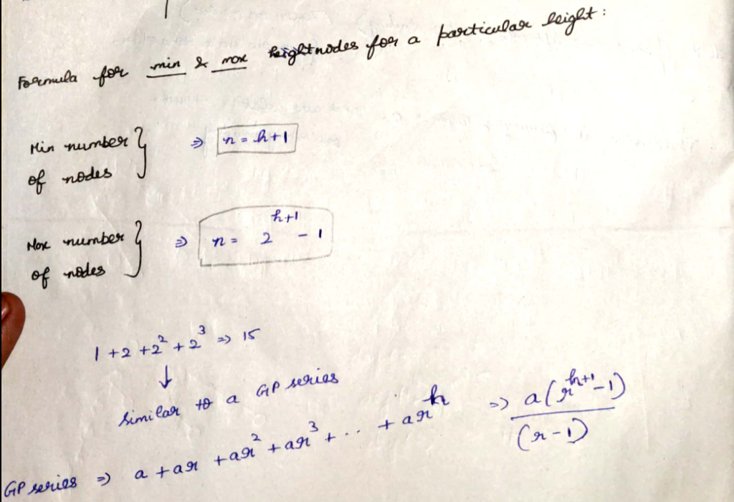





The above is the formula to calculate the number of nodes with given height.  
Find the height if the number of nodes are given

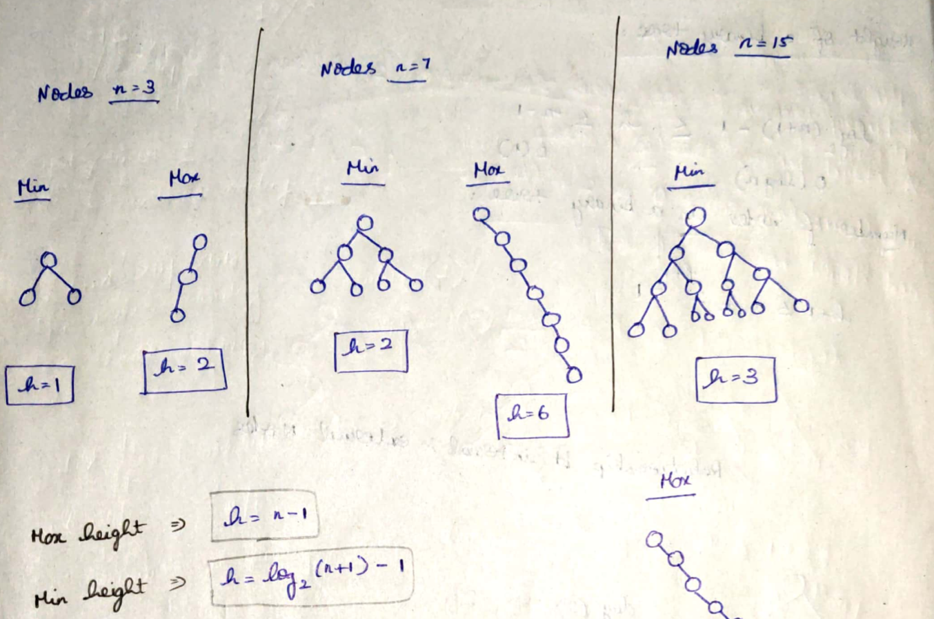  
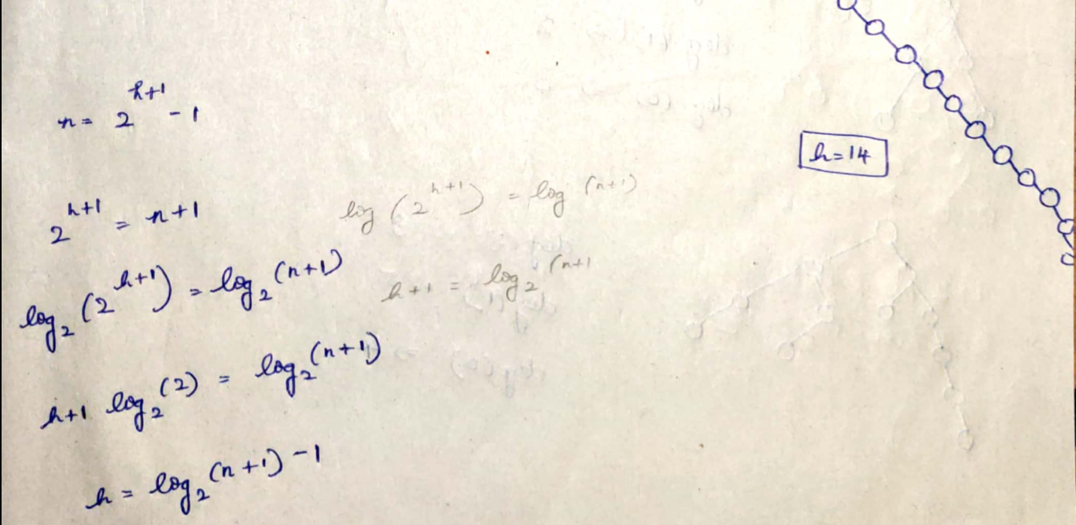



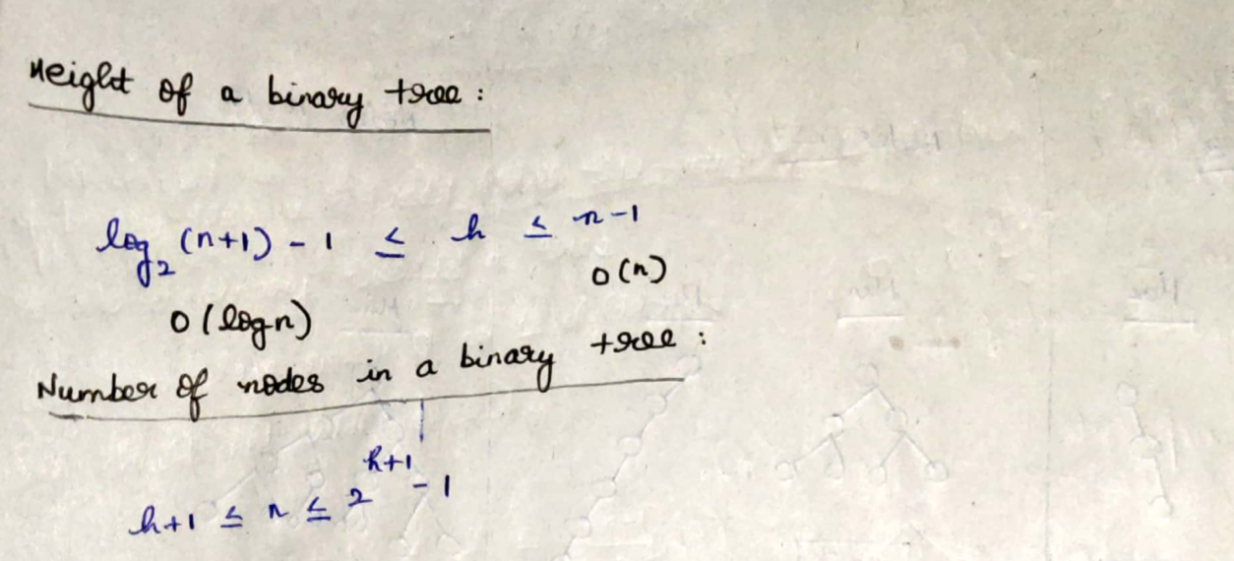

**Relation between Internal and External Nodes**

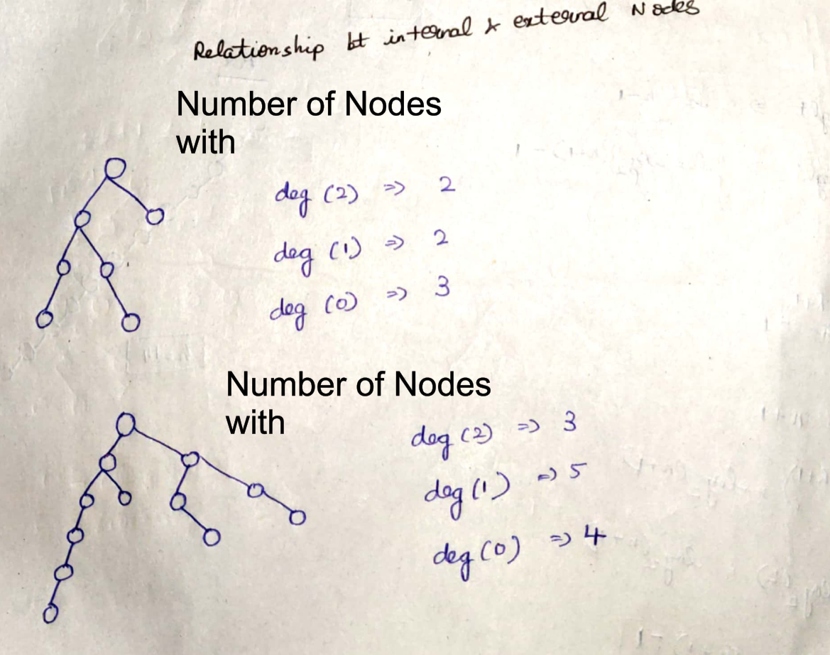

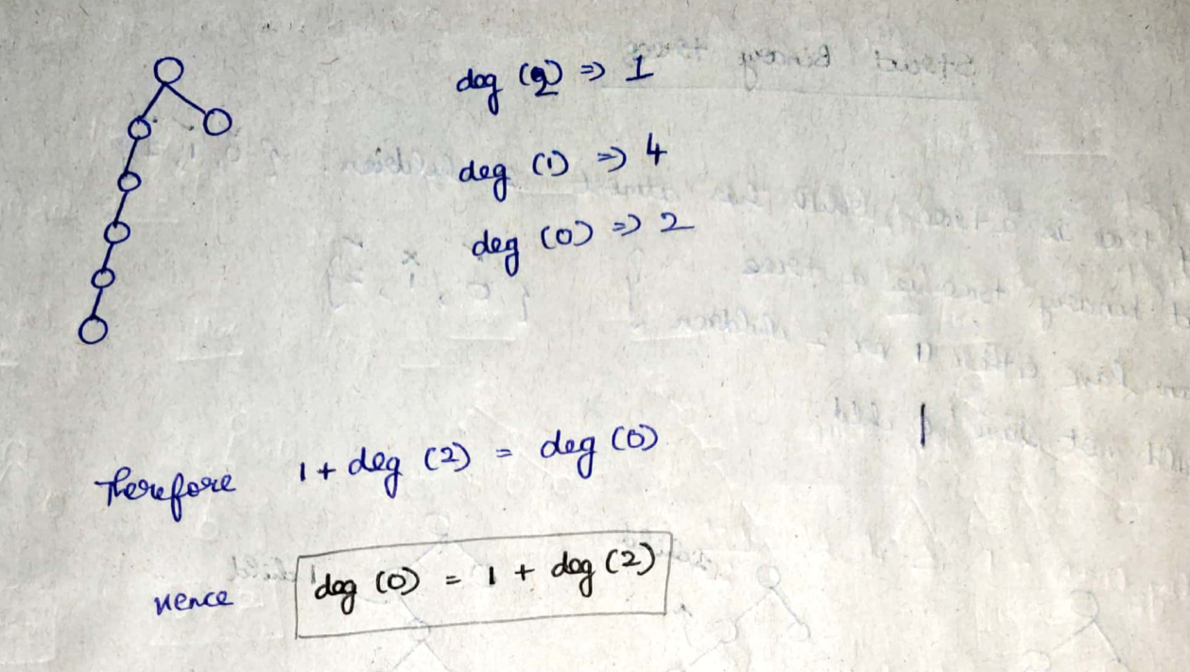

**For a binary tree,   
number of nodes with deg(0) = 1 + number of nodes with deg(2)**

**Strict Binary Trees**

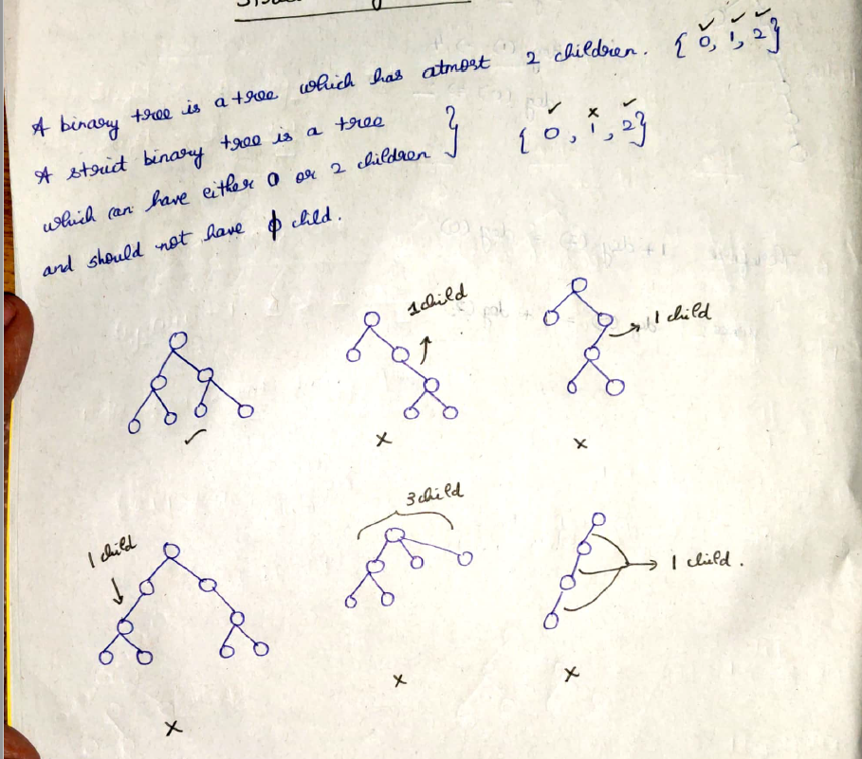 **Height vs Nodes in strict Binary Tree**

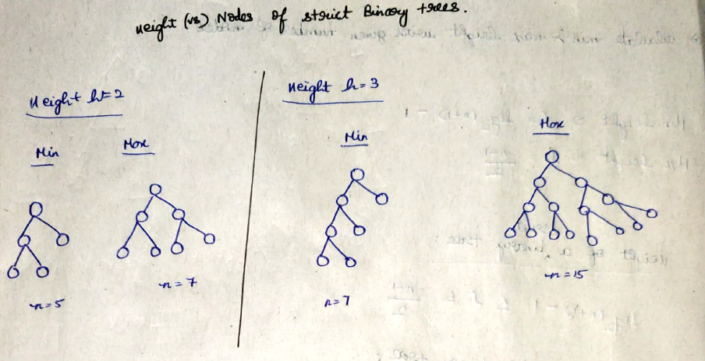

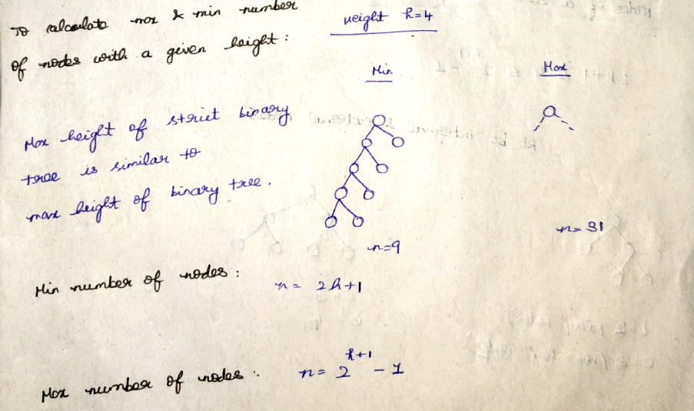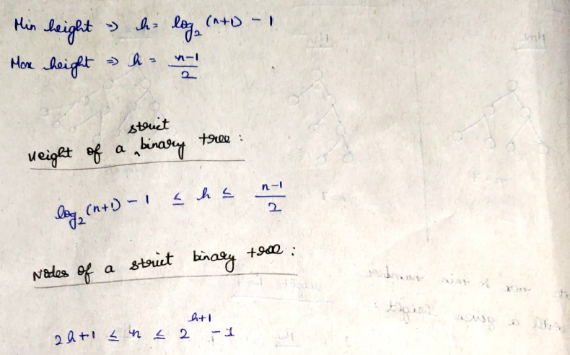





**Relation between Internal and External Nodes in strict binary tree**

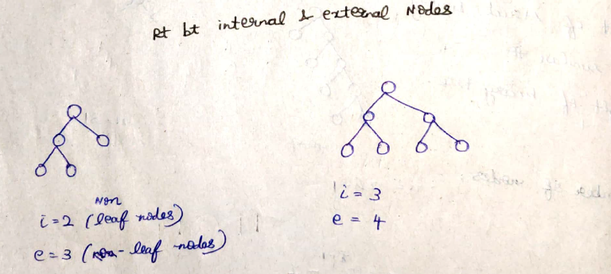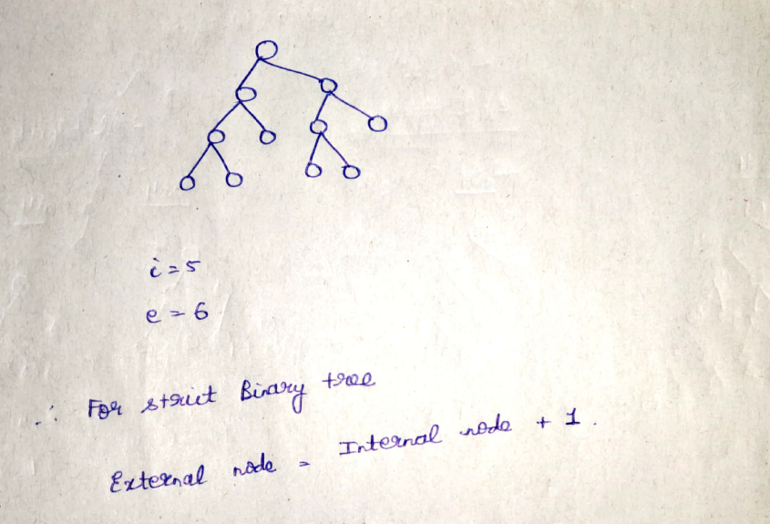

**For a strict binary tree, number of external nodes = 1 + internal node**

**M-array tree**

Every m-array tree can have at-most m nodes

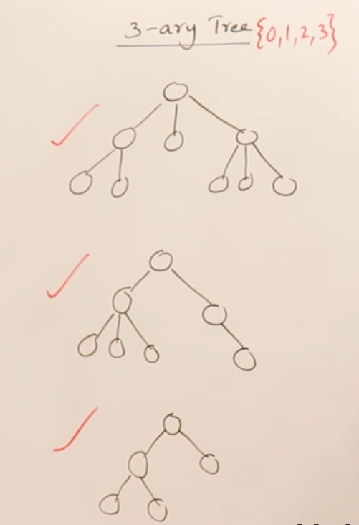 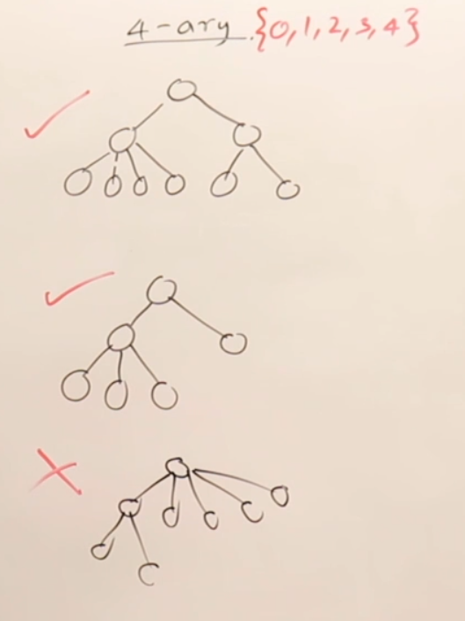

3 array tree can have atmost 3 nodes 4 array tree can have atmost 4 nodes

**Strict M-array tree**

Every strict m-array tree can have either 0 or m nodes.

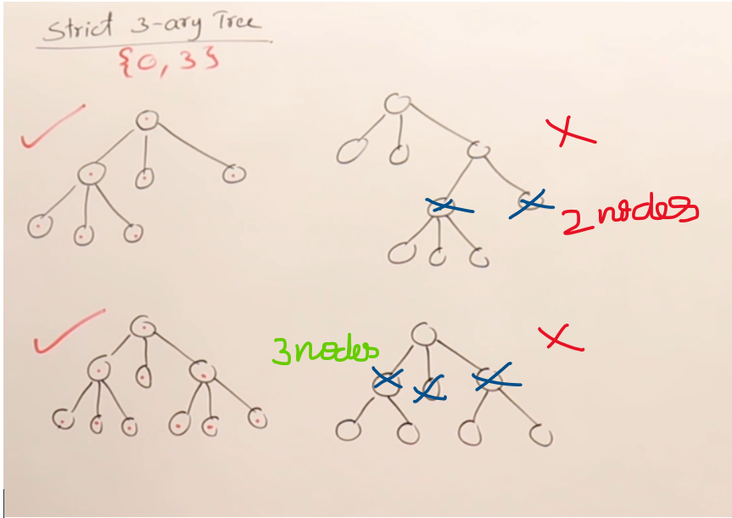

**Height and Nodes of a Strict m-array tree**

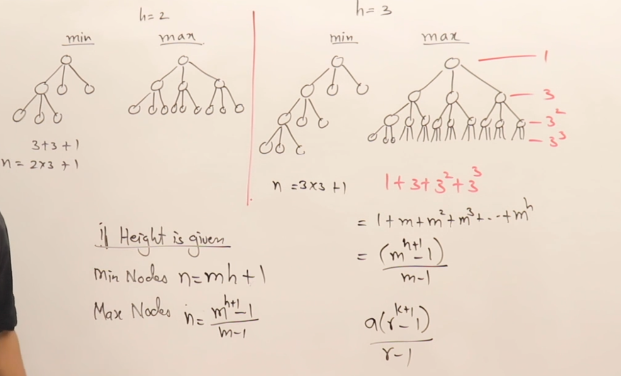



**Representation of a Binary tree**

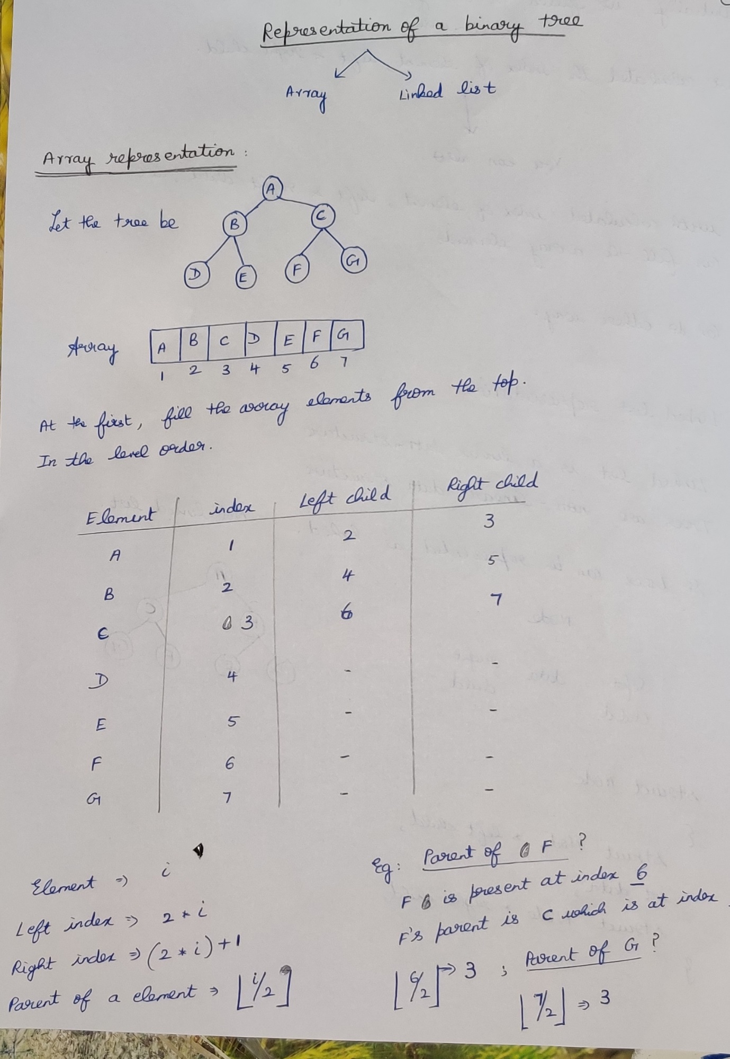

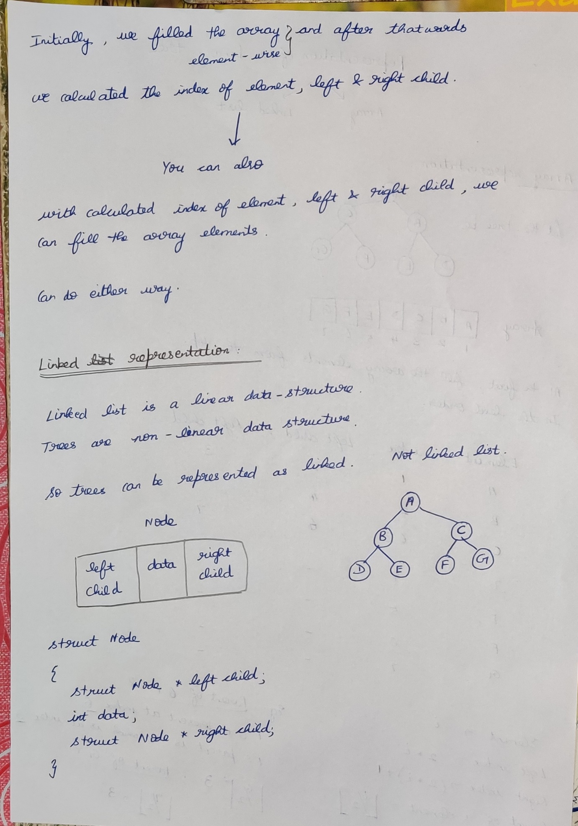

**Full Binary tree (vs) Complete Binary tree**

**Full Binary tree**A binary tree of height h having maximum number of nodes 🡪 Full Binary tree.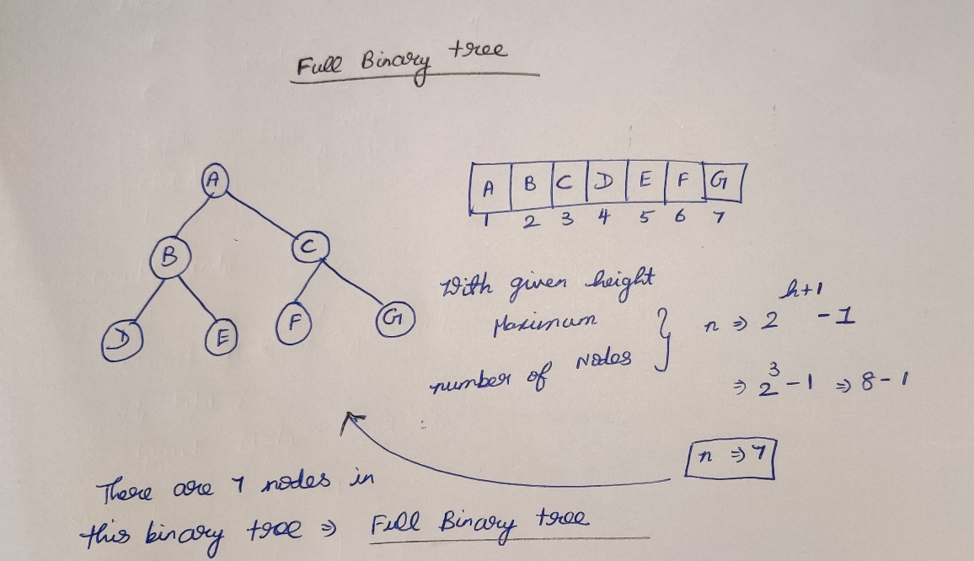

**Complete Binary tree**If a binary tree is represented in an array, then there should not be any blank spaces in-between the elements 🡪 complete binary tree,  
if there are blank spaces then 🡪 not a complete binary tree.

A complete binary tree of height h will be a full binary tree upto height (h-1), and at the last level the elements will be filled from left to right without skipping.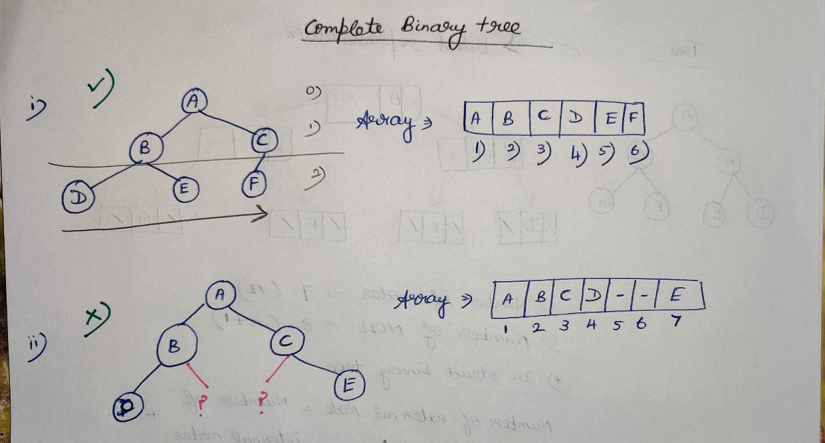  
A full binary tree is always a complete binary tree.

**Strict vs Complete Binary tree**  
 **Complete vs almost Binary tree**

There may be Strict binary complete and Complete Binary tree.  
There may be Complete binary tree and almost Binary tree.

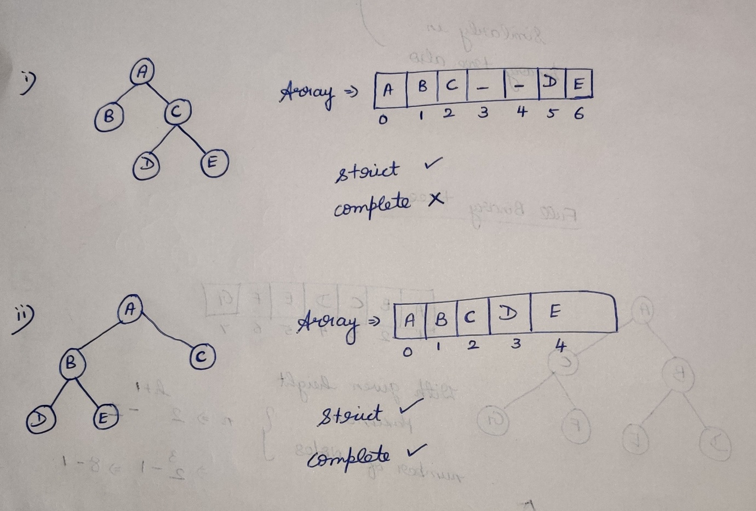  
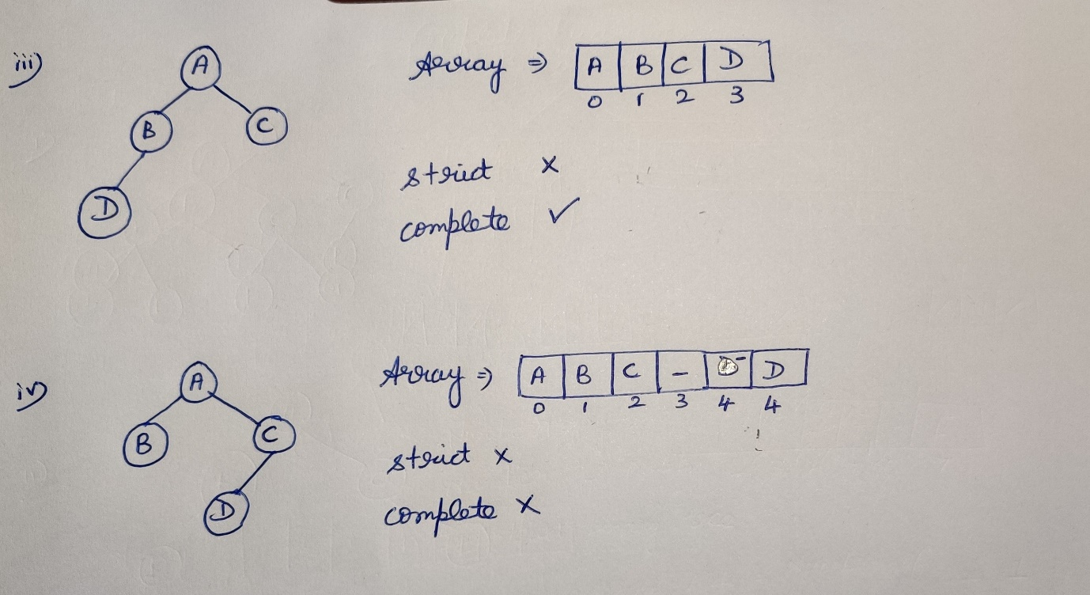

**Relation between Internal and External Nodes**

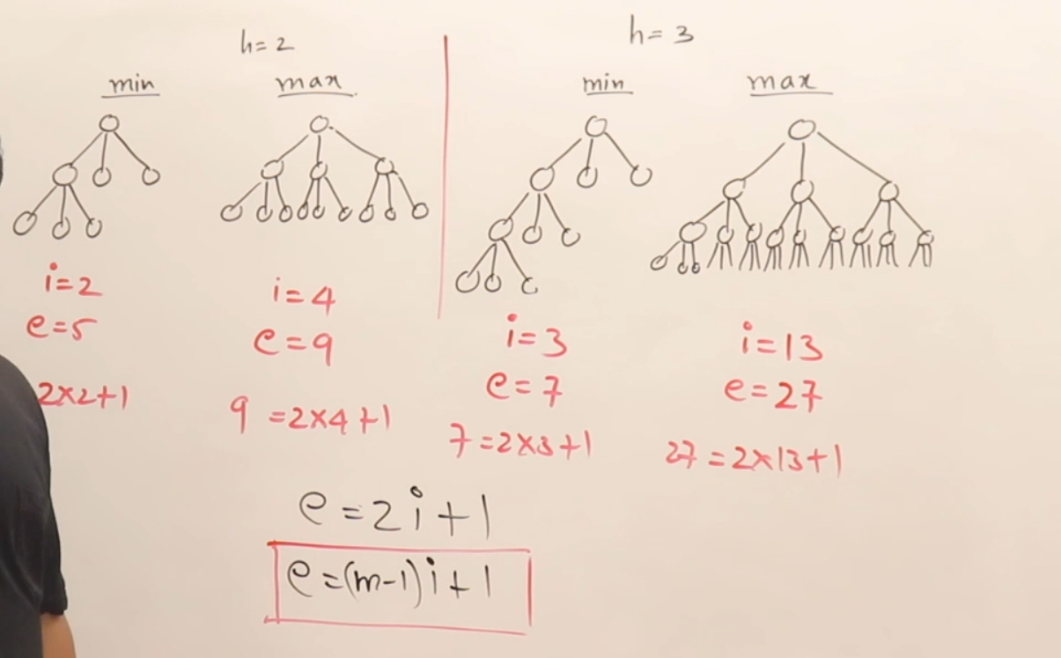

**Tree traversal**

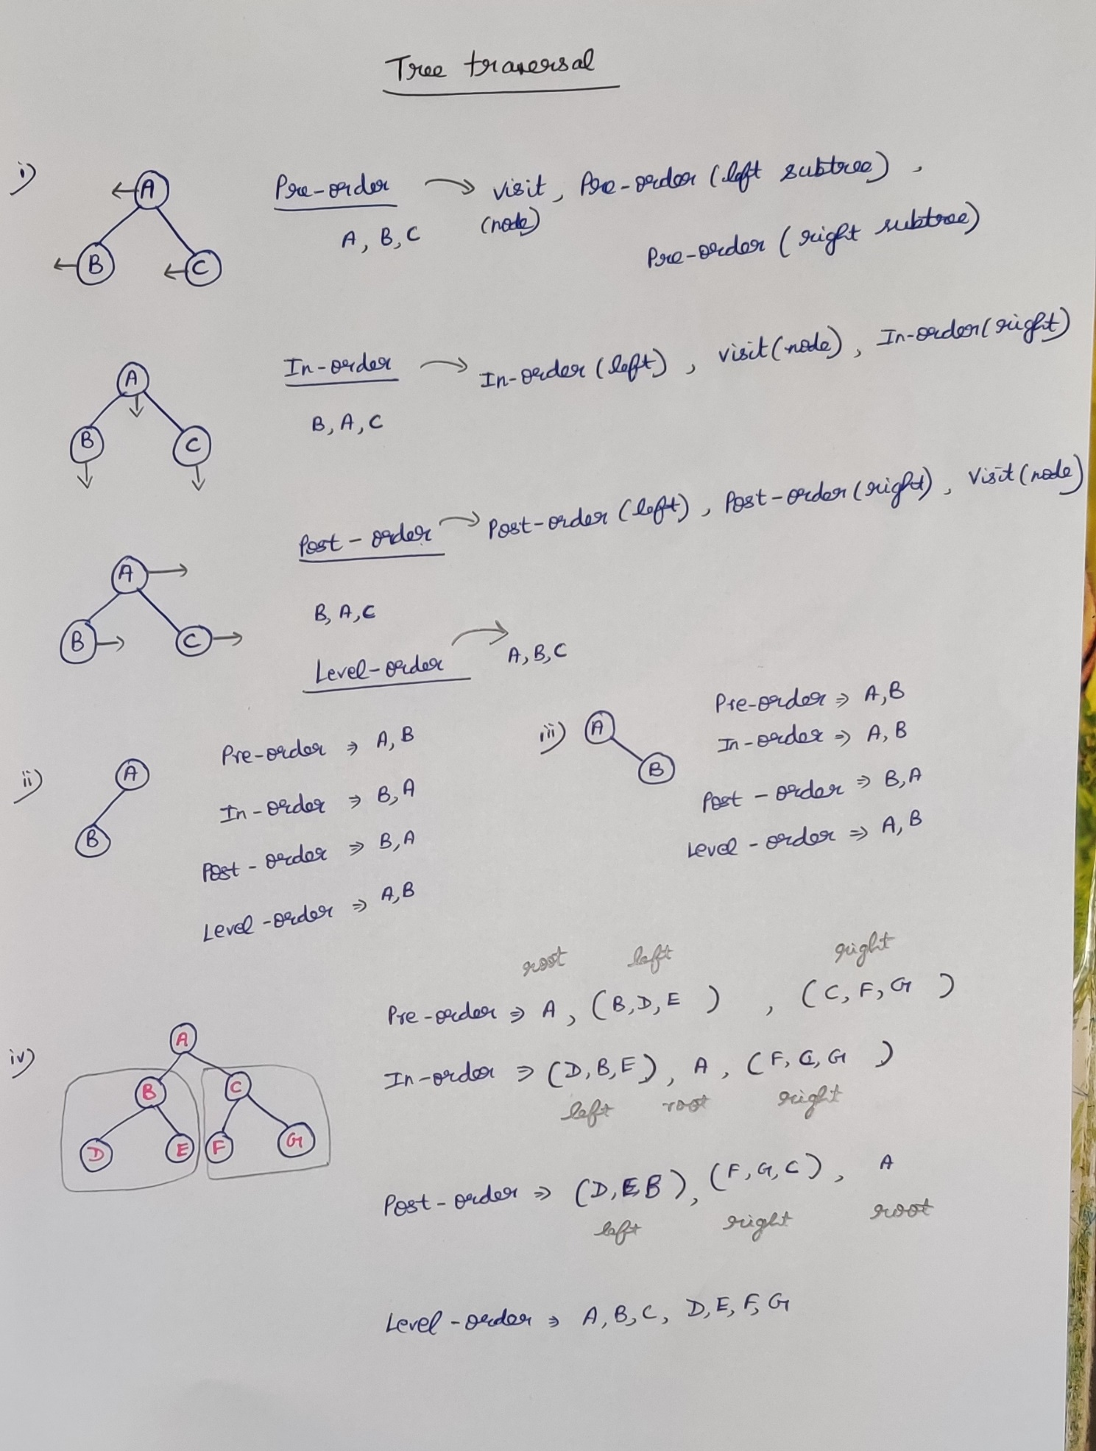

**Method-1**

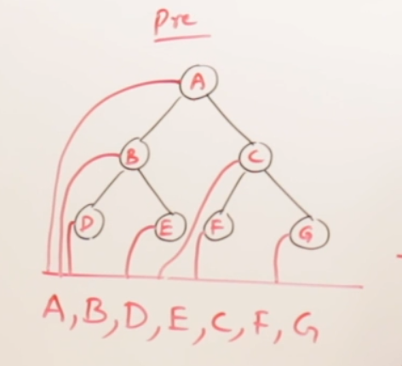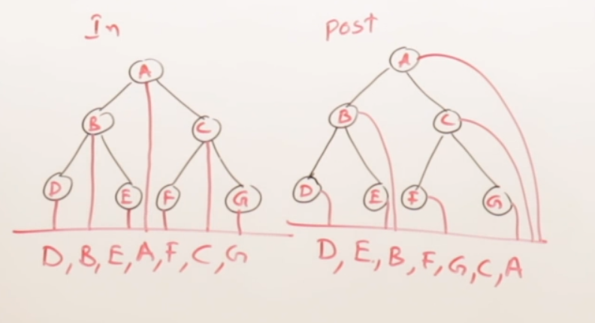

**Method-2**

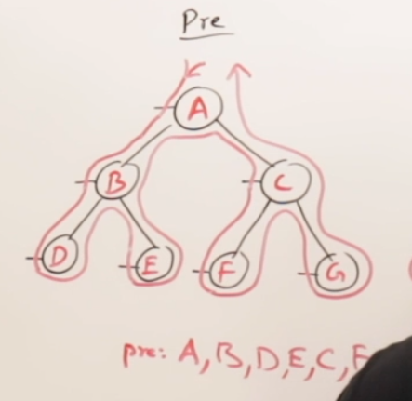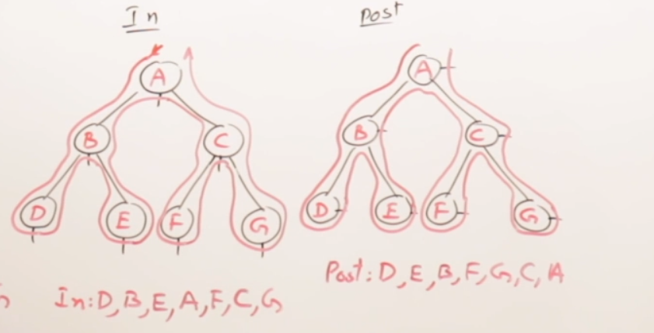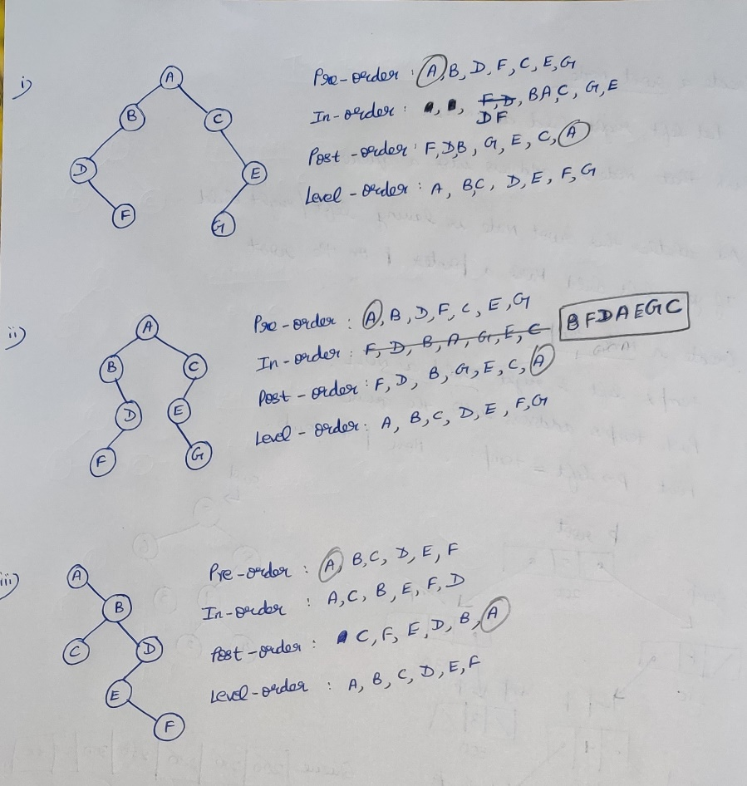

**Linked creation of a Binary Tree**

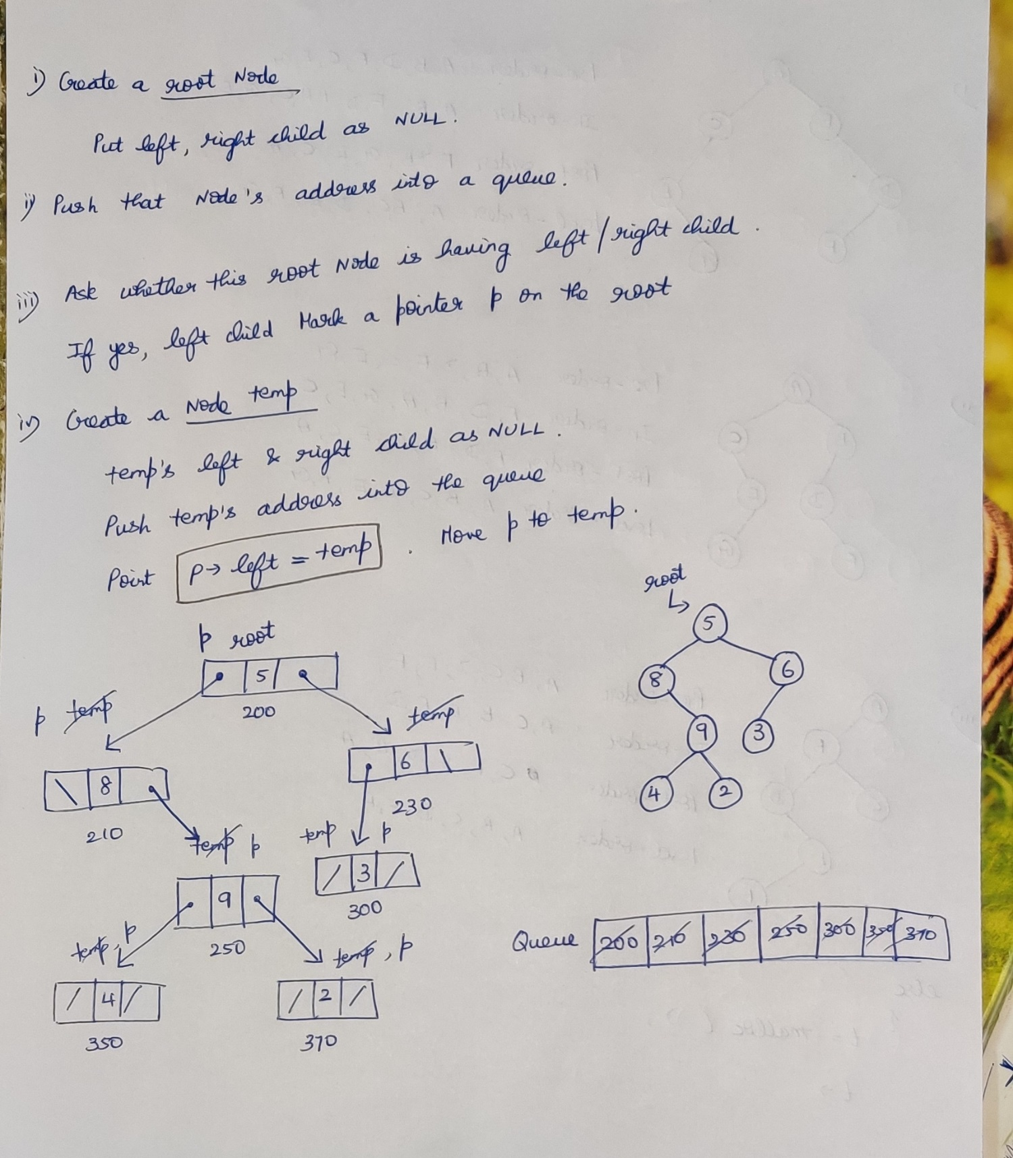

**Algorithm for creating a binary tree**

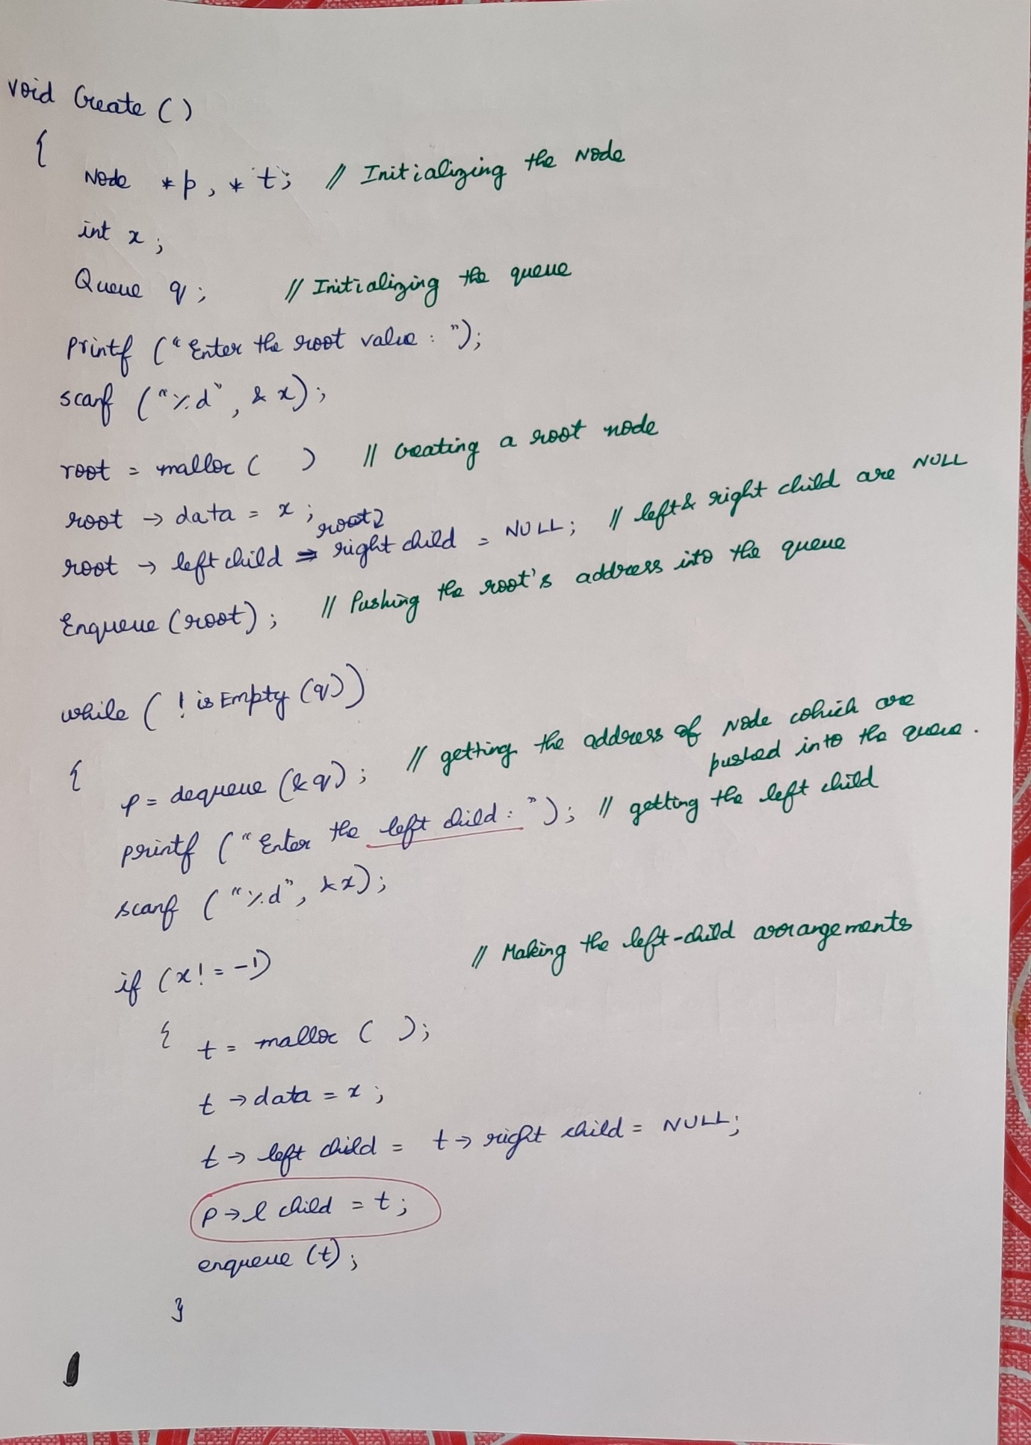

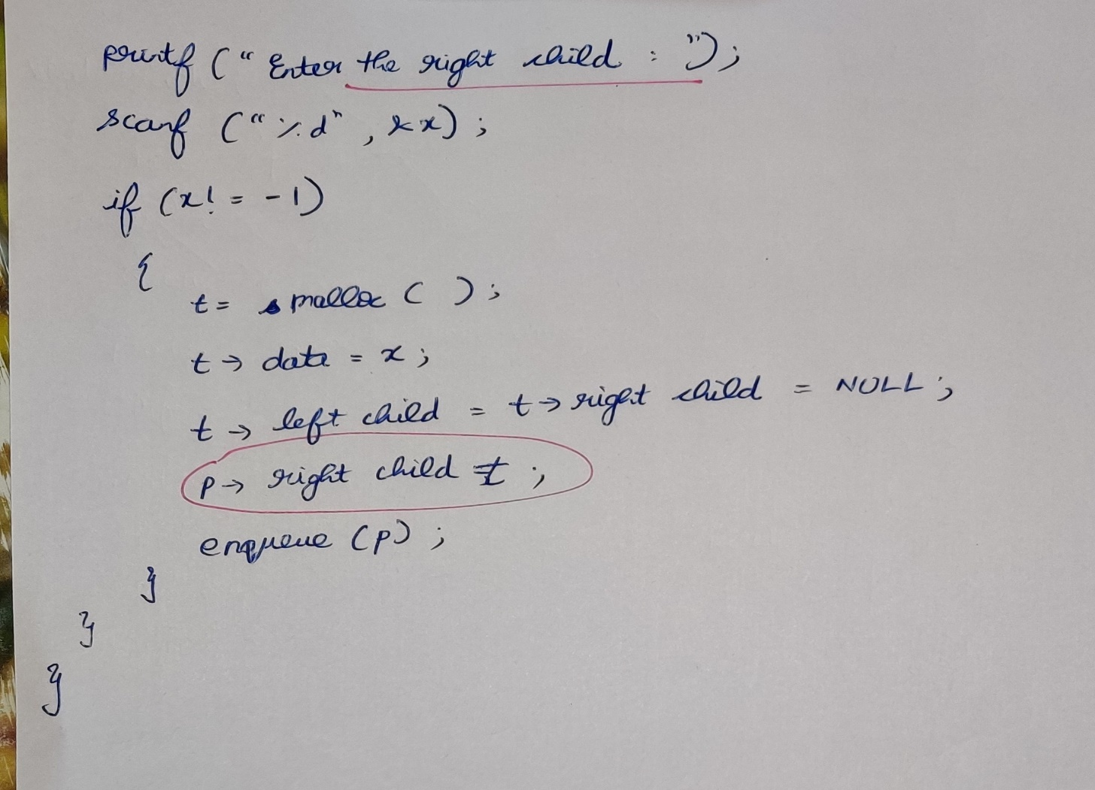

**Algorithm for tree traversal**